**Command line**

**F:\project\aws\all files>ssh -i EC2TUTORIAL.pem ubuntu@65.1.100.180**

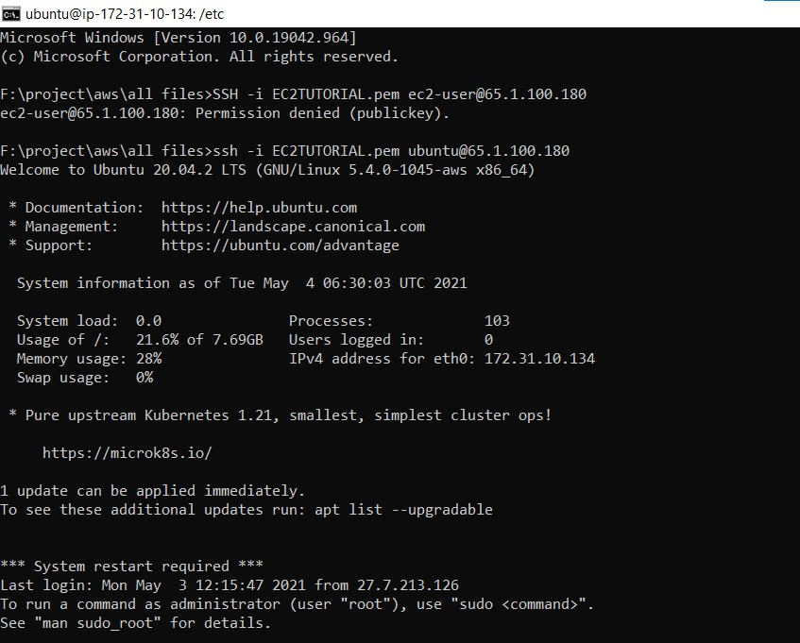

**ubuntu@ip-172-31-10-134:~$ pwd**

**/home/Ubuntu (present working directory)**

**ubuntu@ip-172-31-10-134:~$ ls (List directory contents)**

**ubuntu@ip-172-31-10-134:~$ touch test.txt**

**(created an empty file)**

**ubuntu@ip-172-31-10-134:~$ ls (List directory contents)**

**test.txt**

**ubuntu@ip-172-31-10-134:~$ cd / (change directory)**

**ubuntu@ip-172-31-10-134:/$ pwd**

**/**

**ubuntu@ip-172-31-10-134:/$ ls**

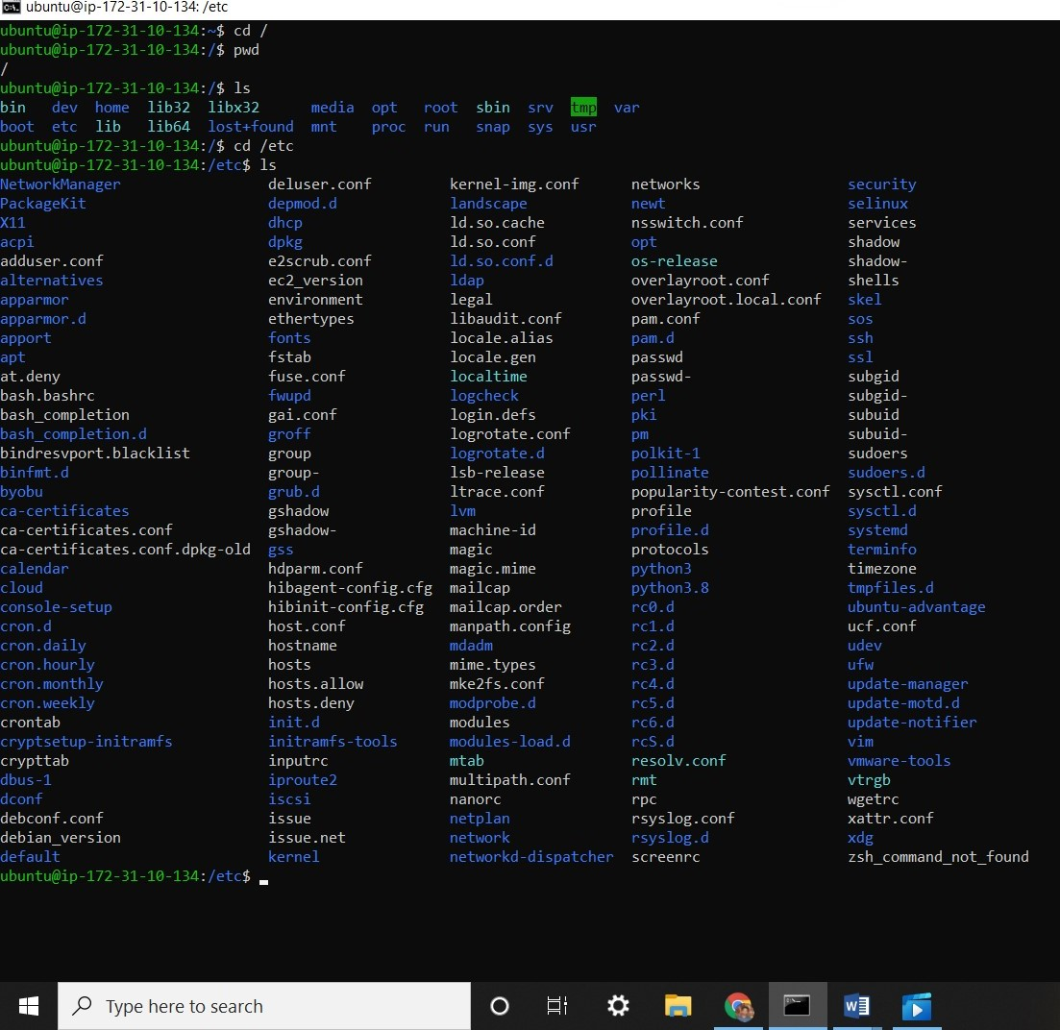

**ubuntu@ip-172-31-10-134:/etc$**

**ubuntu@ip-172-31-10-134:/etc$ ls –help**

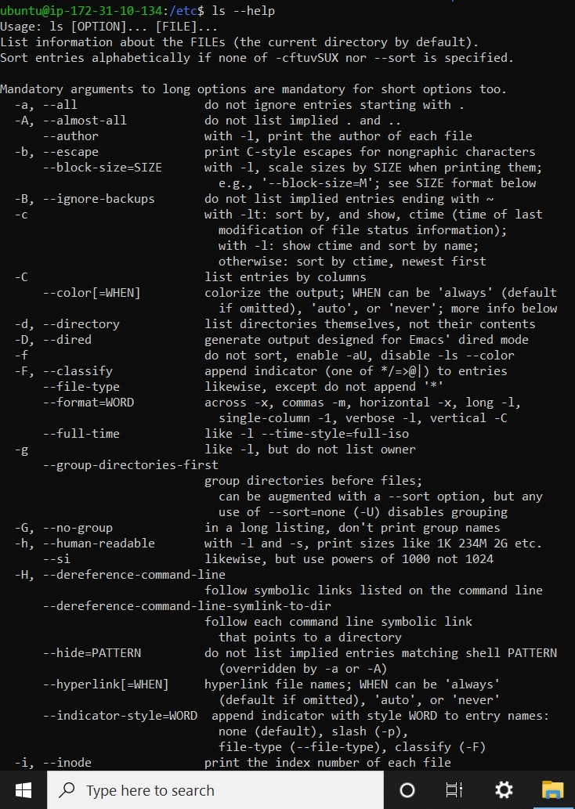

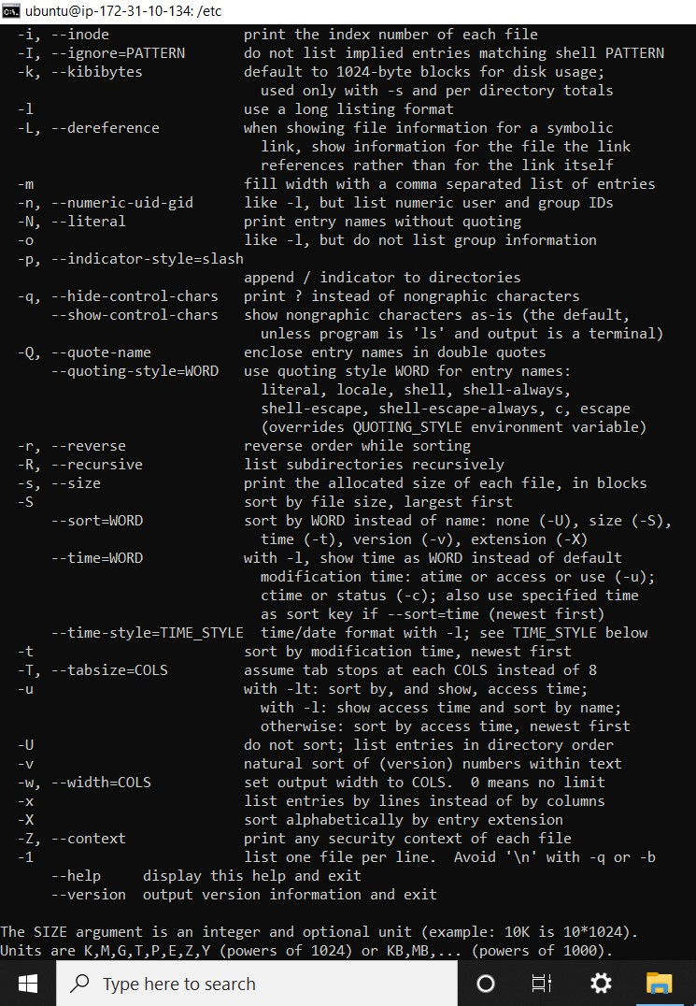

**ubuntu@ip-172-31-10-134:/etc$ ls --help | less**

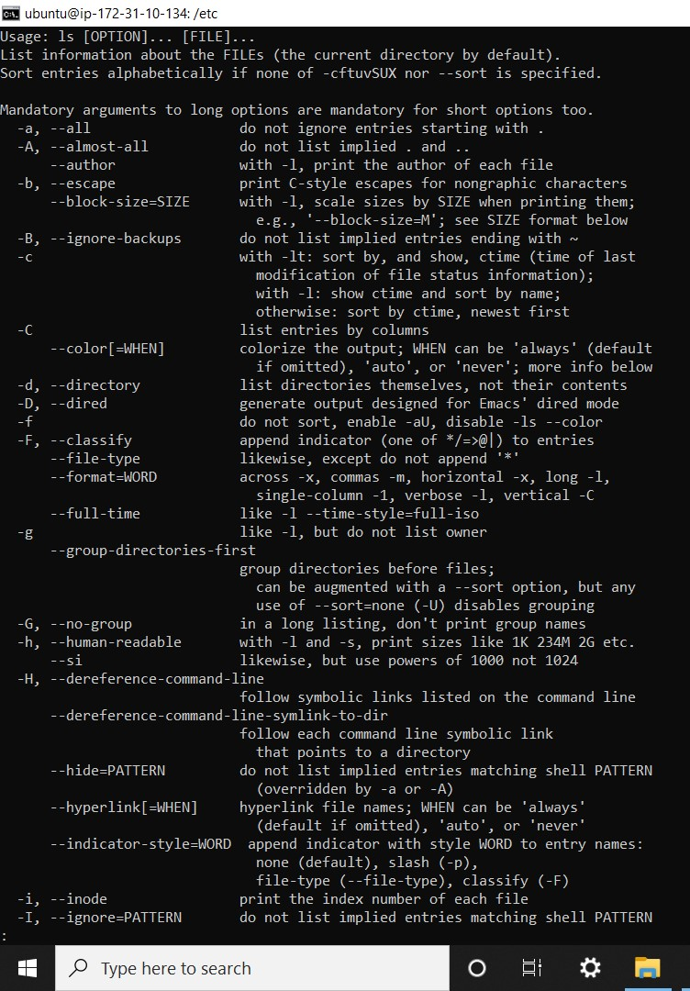

**Q to quit**

**ubuntu@ip-172-31-10-134:/etc$ man man**

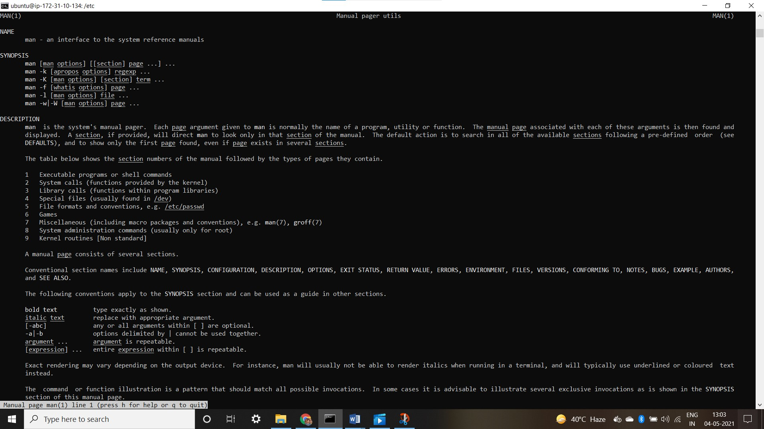

**ubuntu@ip-172-31-10-134:/etc$ man ls**

